**PRIORITY ISSUES**

**Summary:**

In 2021 Inpesca (Instituto de Investigación Pesquera) began a process to adopt an approach in the stock assessment of Chilean hake by fleet. From 1990, Inpesca develop different stock assessment models from VPA in 1990 to statistical cath-at-age models from 2000 until the recent year. However, the fishery of hake is developed by artisanal and industrial fleets, the model was aggregated and did not consider separation by fleets or sex, this approach to the last year presents limitations associated with the increase in not-declared catches by a fraction of illegal vessels. Furthermore, an stock assessment by fleet should be more realistic to generate a model that includes different sources of mortality by fleets and the fraction not declared.

The characteristics of Stock Synthesis (SS) determined that the Inpesca team, select SS to develop the future assessment of Chilean hake, joining with the possibilities to develop diagnostic tests and simulations in the same platform.

The next issues are a list of topics that were selected in this step to improve the model and data generated for the assessment 2021, to generate a robust stock assessment model that allows simulation and Management Exploitation Strategy to Chilean hake.

# Models performance

In 2021 different models were developed to assess the Chilean hake population. The approach was to generate a model by the fleet with official landings (without corrections and corrected landing. Furthermore, a model where the not declared estimation landings were included like a fraction to each fleets. The corrected landings come from Management and Scientific commits, however, it is not completely accepted by the Scientific commits based in the uncertainty of this series.

The different models presented a generally good performance in the fit of landing, medium age and age composition, but in the same way as other models from Inpesca (2020) and Ifop, there is not a fit to the acoustic and age composition in the survey. Thus, this issue is a point to improve and solve in order to select and correct the model structure to the survey index and composition. Some options are check:

## Selectivity options in the acoustic survey (i.e double normal).

## Incorporate watage data input in the model and check the reason that the model does not converge when this data is used instead of growth and weight function and parameters.

# DATA

Chilean hake is probably the fishery with a more extensive data register. The fishery began in the 1940s, always directed to direct human consumption. The long-line artisanal and net boats supply the internal demand of fresh hake, while landings of industrial trawlers are directed to manufacturing export products.

In the case of Inpesca, the monitoring program of Chilean hake began in 1992 by a program over the industrial fleet. Inpesca does not have a system of sampling over an artisanal fleet but with the cooperation of the Fishery Agency (Subsecretaria de Pesca) and IFOP (Instituto de Investigación Pesquera), was possible to get the size composition of the artisanal fleet that was used to generate an age-composition in the artisanal fraction.

The landing time series is provided by SERNAPESCA (Statistic service of the fishery), while the acoustic biomass and age-composition are regular research studies developed by IFOP (Figure. 1). In relation with landing, is possible to extend the series from 1940 at the present but without age composition.

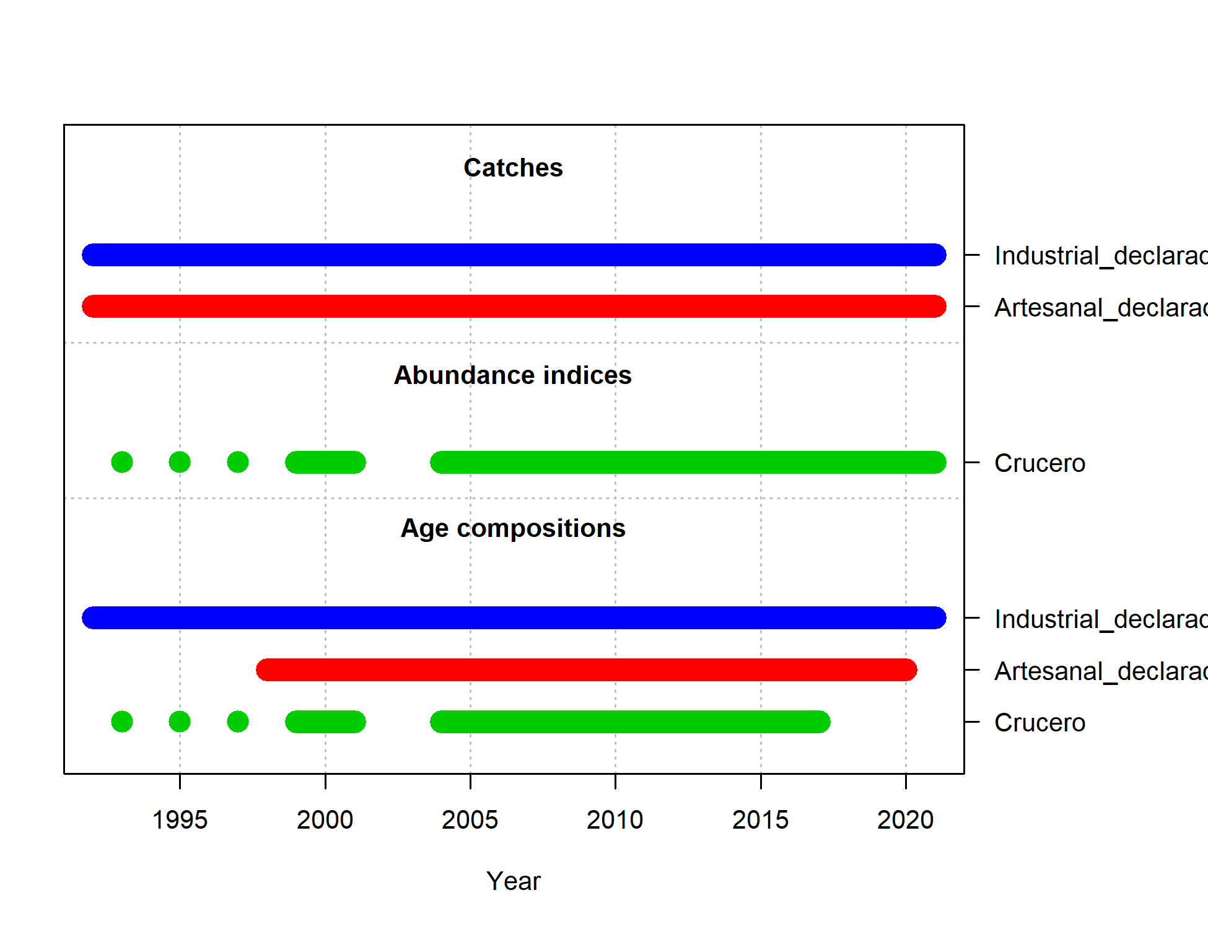

Figure 1. Information to incorporate in stock assessment to Chilean hake in the INPESCA model.

There are different time series of landing:

1. Official landing from national fishery service between 1992-2021.
2. Landing corrected from management committee (stakeholder) from 1993-2015.
3. Landing corrected from scientific commit from 2002-2019.

At the moment the scientific committee uses the base model stock assessment with the official landing input. The uncertainty in the methods used to correct the time series conduct with no consensus between scientists and managers, resulting in adopting the assessment with not corrected landing.

# Diagnostic model

The main objective is to develop a stock assessment model by fleet robust with good statistic performance and fit to the data used. A challenge to the different models in recent years is to fit properly the acoustic and age composition. Both, Inpesca and Ifop assessments presented problems to fit this information. Once the model gets a good performance the next step is to develop different diagnostic to the model that includes: i) retrospective analysis, ii) bias and precision, iii) likelihood profile. On this point, an especially important topic is the great uncertainty in the landings series by this reason we believe that simulation analysis can support management decisions on status and TAC recommendations.

In 2010, the Hake Fishery Scientific Committee set a BRP limit of 20% VSB (Virginal Spawning Biomass), while the BRP target was set to 40% VSB (SUBPESCA, 2010). In the same line in 2016 (SUBPESCA, 2016) was established the Management Plan (MP) to Chilean hake where the objective of management is 0.4 VSB and limit 0.2 VSB with a specification of time to achieve the objective of 7 year.

# Schedule

The next schedule is a proposal to organize future work related to the assessment of Chilean hake. A special issue is to organize a technical meeting to review data and model and develop a framework of assessment of the Chilean hake over the base of the data used by Inpesca to advise the management.

|  |  |
| --- | --- |
| Task | month |
| Get catch-at-age composition artisanal and industrial fleet | 11/2021  12/2021 |
| Increase the age group in the data and model from age 1 - 14 | 12 /2021 |
| Check biological parameters and settings | 12 /2021 |
| Review catchability and selectivity settings | 12 /2021 |
| Prepare documents and data to meet Seattle or Talcahuano. | 3/2022 |
| General coordination to meeting and task | 4/2022 |
| Meeting in stock assessment of Chilean hake (Talcahuano or Seattle) | 5/2022 |